**样题**

1. 职场描述(Presentation) (3 minutes)

**Task:** You are required to talk about the following chart, giving your comments on possible causes of the survey results.

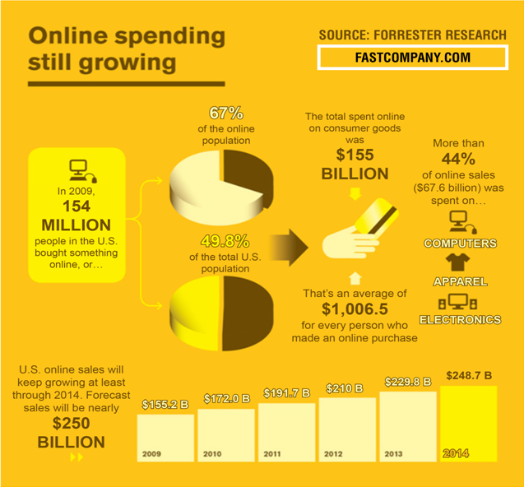

2.情景交流 (Interview) (3 minutes)

Now you’ll see a poster：

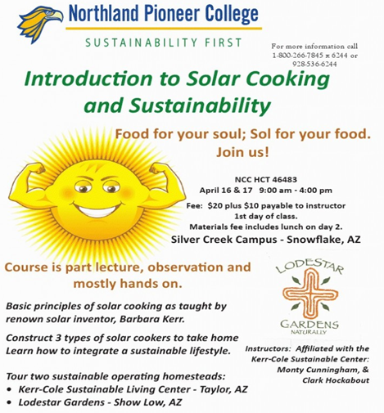

PUBLIC NOTICE of NONDISCRIMINATION: Northland Pioneer College

does not discriminate on the basis of race, color, national origin, religion, marital status, gender, age or disability in admission or access to, or enjoyment in its educational programs or activities. For more information call 1-800-266-7845×6244 or 928-536-6244.

**Note:** Food for your soul; Solar (Sol) for your food. Sustainability: 可持续性

**Task:** Suppose you’re the secretary working at Northland Pioneer College and someone is interested in the course. You will talk

with the person and answer his /her questions.

**Contestant:**a secretary at the college

**Question Master:**a person who is interested in the course

**Numberof Questions:**8-10

3.职场考验(Role-Play) (8-10 minutes)

**Task:** Suppose you are a team of staff of a Chinese candy

company, and you meet to discuss on a new product that should

be successful for the Canadian market.

**Requirements：**

1. Each team member should play a role to ensure this product a success according to his/her role.
2. Any final decision or agreement is not necessarily required.

**Roles for the team members:**

a RD designer from Research and Development Department;

a salesperson from Sales (or Marketing) Department;

an ad planner from Advertising Department;

a QC engineer from Quality-Control Department;

a PR representative from Public Relations Department (only for the fifth member).

4.即席辩论（Debate） ( 5 minutes)

**Background(背景信息):**

On May 13, this year’s Mother’s Day, mothers in China received an outpouring of gifts and greetings from their children. For the past years, along with many other Western festivals, Mother’s Day has become popular with the Chinese. However, some people believe China should draw on its own traditions to express gratitude and respect to mothers in a Chinese way, rather than borrow from a Western custom.

(今年5月13日是母亲节，中国的母亲们接到了无数来自孩子们的祝福和礼物。在过去几年中，和其他很多西方节日一样，母亲节也开始在中国盛行。然而，有些人觉得中国人不应仿照西方的模式，应该立足于中国传统，用传统的方式表达对母亲的感激和尊敬。)

The question is: Do we need our own Mother’s Day?

(题目：我们需要立足于中国传统的母亲节么？)

For: Yes.

(正方：我们需要。)

Against: No.

(反方：我们不需要。)